CHIKWAWA DISTRICT FLOODING DISASTER SITUATION REPORT - 11/03/ 2019
- INTRODUCTION
From 5 March up to 8 March Chikwawa district experienced heavy rains leading to serious damages on public infrastructure, properties, crops as well as loss of lives, both of people and livestock. All eleven (11) T/A's in Chikwawa district have been affected by the March 2019 floods. So far, due to the impact of this flooding, 8 people have been confirmed dead (their bodies have been recovered) and from the initial 11 people that were missing, 9 have been found, but 2 people are still missing.
- BACKGROUND
It is worrisome that Chikwawa had already been affected by floods in January 2019, and heavy winds in February 2019. The DCPC through its humanitarian clusters was already in an activated mode. Therefore, right away, on Friday 8 March 2019, the DCPC embarked on damage and loss assessment exercise in the district. However, although we have managed to visit some of the affected places, we still have some areas which are impassable by road. And furthermore, the district was cut off from Blantyre in between Thabwa roadblock and Kamuzu bridge, which delayed the rapid response to affected areas in the East Bank site. Inter-cluster meetings started on Friday 8 March and on the same day some live saving operations like search and rescue were undertaken. Food, blankets and tarpaulins were distributed to evacuation sites, like Mwalija camp. Having noted that the magnitude of disaster is quite extensive, we also informed the national level team to help with some search and rescue operations. These are now, due to delay because of the broken road, on the ground to support with the inaccessible areas. On this same Friday we also opened an Emergency Operation Centre at Malawi Red Cross Shelter.
- INFORMATION ON INTERNALLY DISPLACED PEOPLE
Although the numbers are still increasing, we currently have 33 camps in Chikwawa district, housing 32,067 people, which is 7,529 households. In total more than 12,755 households, meaning 53,765 people, are affected. More information can be found in the table below:
TA | TOTAL HH | TOTAL POP | MISSING | DEATHS | NUMBER OF CAMPS
MAKHUWIRA | 2854 | 8158 | 1 | 6 | 10
LUNDU | 2536 | 12340 | 0 | 1 | 3
MASEYA | 1205 | 5269 | 0 | 0 | 6
NGOWE | 488 | 2079 | 1 |  | 2
MASACHE | 532 | 2500 |  |  | 0
KATUNGA | 1102 | 5049 |  |  | 4
CHAPANANGA | 998 | 2650 | 0 | 1 | 1
KASISI | 640 | 3200 |  |  | 1
NGABU | 2217 | 12105 |  |  | 6
MLILIMA | 183 | 415 |  |  | 0
NDAKWERA | 85 | 425 |  |  | 0
Total | 12755 | 53765 | 2 | 8 | 33
The most critical thing is that some of the camps that were already there due to the January 2019 floods, have also been affected to the extent that people have moved to other new camps. For instance, Peace of Mind Church under GVH Bester in the area of Paramount Chief Lundu, as you can see in the 1 picture below:

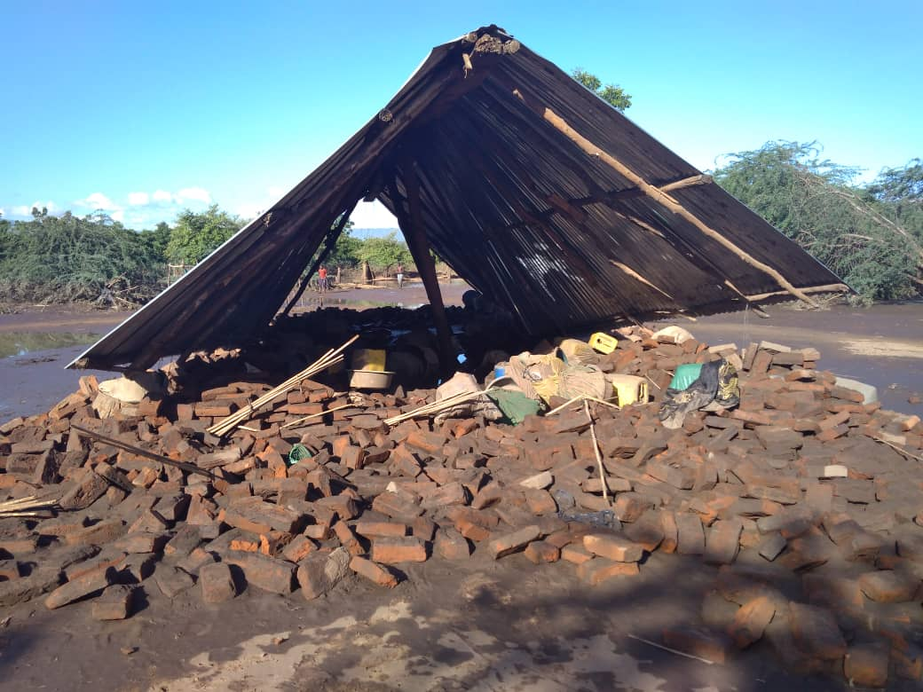

- SERVICES ALREADY PROVIDED:
Organization | Services rendered
DODMA / District Council | Provision of relief items, coordination of disaster response (including search & rescue and assessments), human resources, transport
Malawi Red Cross Society | Provision of relief items, coordination, search & rescue, transport (both fuel and vehicles), human resources
Goal Malawi | Transport, human resources
WFP | Transport, search & rescue, human resources
Eagles Relief and Development | Human resources
World Vision international | Human resources, transport
CYESE | Human resources
CADECOM | Human resources, shelter materials (tents)
Habitat for Humanity Malawi | Human resources, Transport
CAVWOC | Human resources
Disability Mission | Human resources
Water for People | Human resources, transport

- MAIN CHALLENGES:
For responders:
- Transport: many areas are still inaccessible due to damaged road infrastructure or high water levels. Also, few vehicles are available to support the response.
- Finances: there is no clear budget line for disaster response and recovery in the district. There is need for funds to support the procurement of fuel, stationary, allowances, airtime for communication and internet, as well as relief items.
For affected people:
- inadequate shelter facilities
- inadequate WASH facilities, fear of cholera
- not enough food for everyone
- Protection: hostile treatment by the host community, limited child-friendly spaces and security concerns on PWA's
- Health: High risk of malaria and water borne diseases

We will continue to update the figures as we continue witour rapid assessments and verification exercises. More detailed information and pictures are also attached below;.

Rescue Operations in Mwalija Village using District Council's and MRCS's boats........

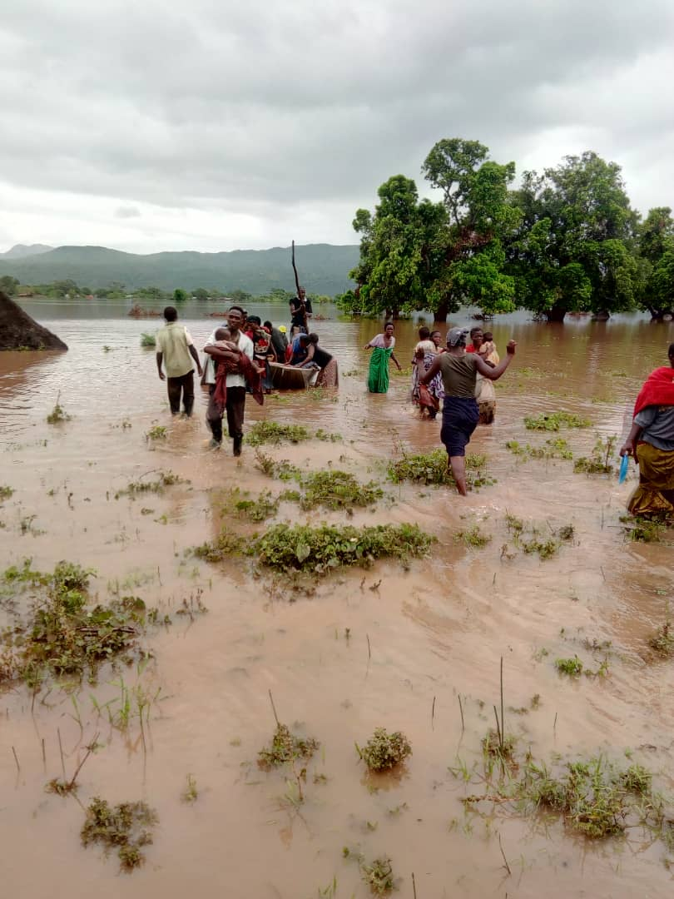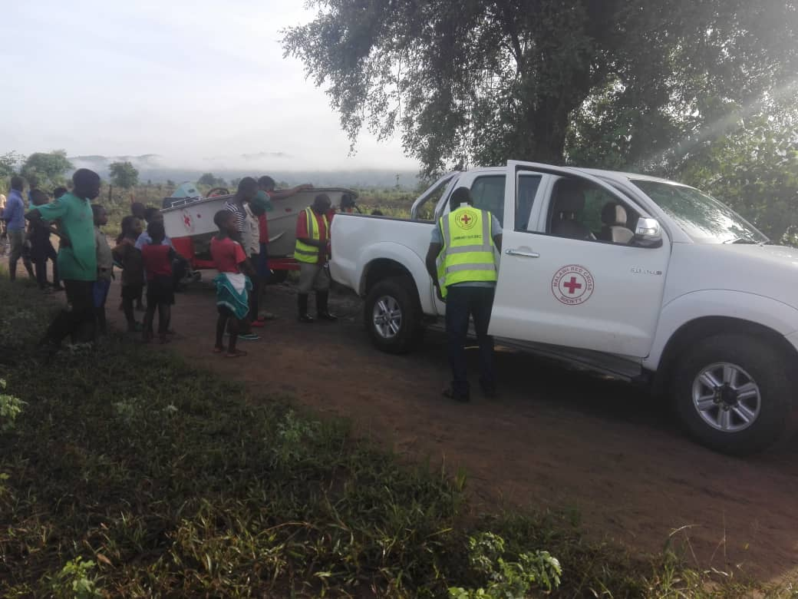

Marine Officials Commissioned by Dodma to support rescue operations and ferry food commodities to Mazongoza camp in T/A Makhwira using WFP boat.........
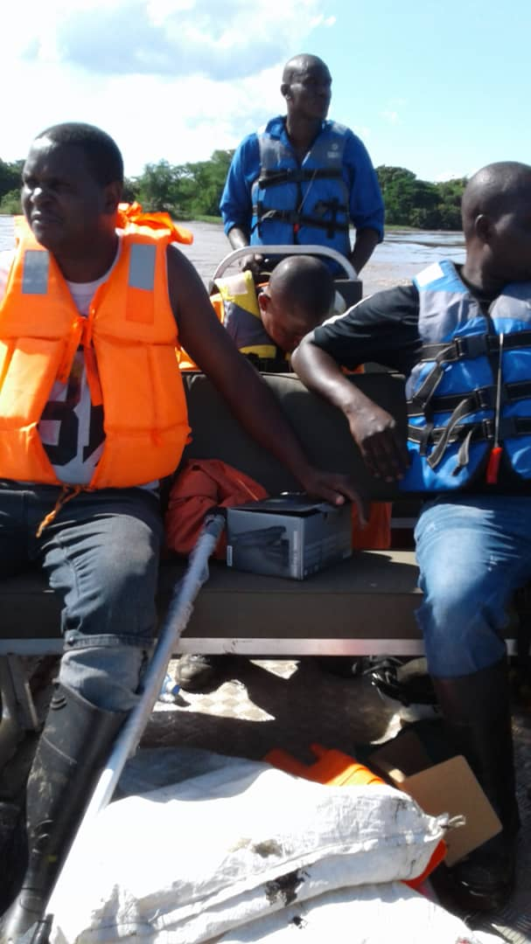

Inter-Cluster Coordination Meetings..............
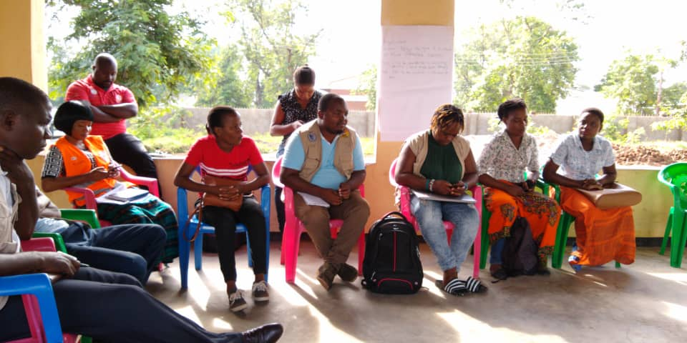
Data collection during disaster assessments ..................
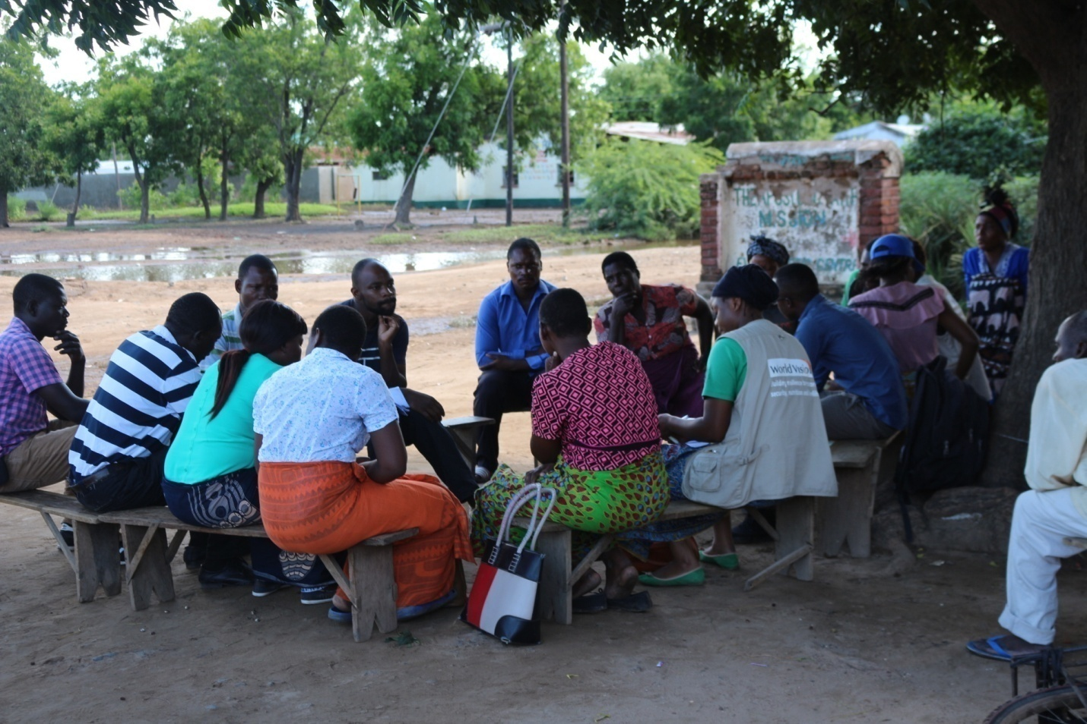

Serious flooding of Shire river along Kamuzu bridge.............
