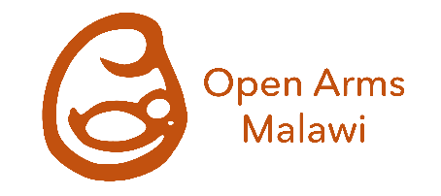
Why we need your help

Open Arms Malawi

(Charity No: 1171686)

We provide 80 orphaned babies in Malawi with care, food and shelter, in one of our specialist infant homes. We support over 650 children in their communities with advice, health care and early education.
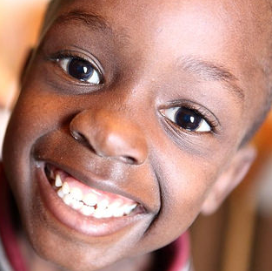
Today, 1,890 babies will be born in Malawi. 320 will become orphans - half because of parental HIV/AIDS. 87 will die before their first birthday from either malnutrition or illness.
Staying with their wider family is almost always the best solution for an orphaned child. But, for those of breastfeeding age, there is a real problem. Formula milk in Malawi costs about £20 a month. Yet, 62% of Malawian families, survive on less than £1 a day. For many, keeping an orphaned baby alive is simply unaffordable.
Open Arms Malawi provides a unique solution. At our two infant homes in Blantyre and Mangochi, we provide milk, accommodation and medical care for 80 orphaned babies until they can walk, talk and eat solid foods. At age two, when they are no longer reliant on milk, 85% return to be cared for by their wider family and community. Without our help, most of the babies in our care wouldn’t survive.
As we’re the only provider of this service in southern Malawi, some desperate families travel up to 100 kilometres to place a baby in one of our homes, after referral by the Social Welfare department. Over the last 21 years, we’ve returned over 700 healthy two-year-old children to their families to become positive and productive contributors to their community and country.
We need your support to help us continue this work. It costs £96,972 a year to run each of our infant homes. Your support will significantly reduce the risks of death for up to 80 children, and enable them to become part of Malawi’s future.

Sainabu’s Story
Sainabu was brought to us at two months old, weighing just three pounds – a third less than a typical baby of that age. She had been born prematurely and sadly her mother died of eclampsia a few weeks later.
We placed Sainabu in ‘Kangaroo’ care at Blantyre Infant Home. This involves a baby wearing just a small nappy and hat, and living in a swaddling sling with direct skin-to-skin contact with their carer.
Sainabu responded well. Her weight gradually increased and by the time she reached one-year old, she was a happy, healthy child. She lived with us for two years, when we returned her home to her Grandma.
As with all returnees, we continue to check Sainabu’s progress regularly. Unfortunately, floods and poor harvest in 2016, meant when we last visited Sainabu’s family they had no food, and she was showing signs of malnutrition.
We immediately provided the family with fortified flour, to enable them to make a nutritious porridge. Later, we gave them fertiliser and maize seed to help grow crops for the coming year.
Sainabu’s story, shows the importance of not only looking after the orphaned babies, but also checking on their progress when they return. We don’t simply present the family with another mouth to feed, but support the whole family when circumstances turn against them – for example providing food to families affected by 2016’s drought.

How our support helps orphaned babies and their families
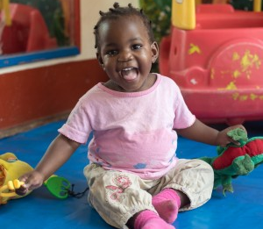
At our Blantyre and Mangochi infant homes, babies are cared for by a paediatric nurse-led team, providing medical care alongside food and development. Each baby is assigned to a ‘Mum’ who becomes their primary carer until they leave at around age two.
The children receive milk and care to help them overcome the negative effects of malnutrition they may have suffered prior to arrival. Southern Malawi has the highest rate of stunted child development in the country. Once a child returns home, our Outreach programme ensures they continue to receive support. Each child goes home with toys, clothes, a mosquito net and food to help keep the costs to the family low.
We regularly check on the child’s health and development for the next three years, providing seed and fertiliser to help the family grow crops. If needed, we provide additional food parcels or small monthly payments to help the family provide care.
We’ve set up nine rurally-based Nursery Schools, each providing nursery care, education and a daily meal for up to 70 children from age two to five. This not only supports the children, but also enables families to plant and tend their crops. If needed, we provide communities with additional food in an emergency. For example, in 2015 we distributed 30 tonnes of grain, maize and fertilizer to help villages affected by flooding return to self-sufficiency.

Not every orphan we support can go home
Whilst we strive to return children to their families, sadly not all do so. Each year, a small number die, primarily from HIV/AIDS or from the effects of malnutrition.
At age two, some children don’t have identifiable families, or have families unable or unwilling to care for them. For these children, we continue to provide food, shelter, education and care in our Harrogate House centre in Blantyre until age five. They then join one of our five foster homes run by a house mother to create a new family.
We currently have twelve children in Harrogate House, and 39 in foster homes. We’re extremely proud that four of our long-term cared-for children recently achieved entry to Malawi’s top secondary school, which will give them a world-class education and help them contribute positively to Malawi’s future.

Further information about our work
We very much hope you will be able to support infant care in Malawi. If you would like further information about how you could help, we’d be happy to discuss opportunities. Please contact Claire Collins by phone on 01423 530129 or email at claire@openarmsmalawi.org.

