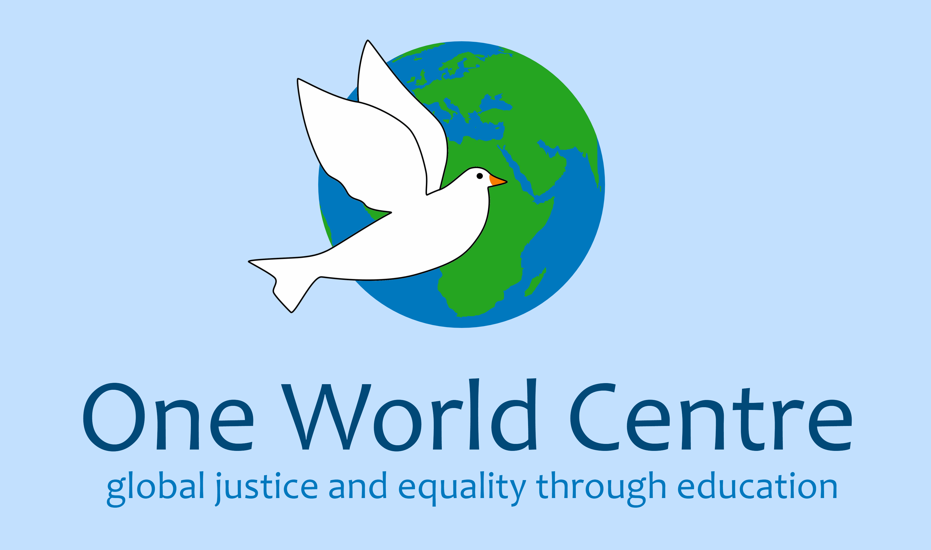
Useful websites:

www.oneworldcentre.org.uk

www.scotland-malawipartnership.org

www.jts.co.uk

www.fairtrade.org.uk

www.signpostsglobalcitizenship.org

www.learningforsustainabilityscotland.org

www.schoolsonline.britishcouncil.org

Useful contacts:

SMP Youth and Schools Officer:
Emily@scotland-malawipartnership.org

One World Centre - Sally Romilly:
Sally@oneworldcentre.org.uk

Practical Ideas
for Exploring
Global Citizenship
in Schools
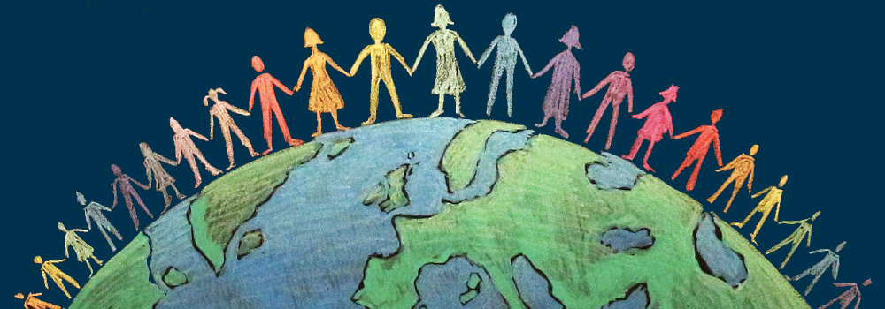

Agenda

16:30 – 16:45 Welcome

16:45 – 17:00 One World Centre, Dundee

17:00 – 17:10 Just Trading Scotland

17:15 – 17:25 Scotland Malawi Partnership

17:25 – 18:30 Carousel of discussion groups:

Fairtrade

Art/film/animation/fiction books
for exploring Global Citizenship

School partnerships

Sustainable Development Goals

18:30 – 18:35 Closing

18:35 – 19:00 Hot food and networking
Your notes from the carousel:

Ideas for exploring SDGs
in your school:

- Each class across the school explore one (or more) of the SDGs and discuss how the school can contribute towards its targets
- Host an event in your school – coffee morning/evening event – to raise awareness about the SDGs in your community – ask learners to present
- Compare Scotland with another country against each SDG and look at how both countries are working towards targets
- Show a short video or hold a school assembly to introduce the SDGs. Lots of ideas at: www.worldslargestlesson.globalgoals.org
- What topic are you currently studying? Explore which SDGs are the most relevant. How can what’s learned in class contribute to achieving the goals?
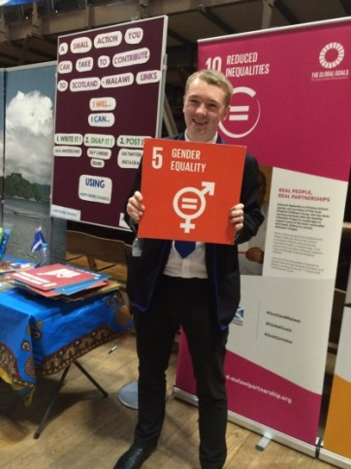
- Think about the importance of everyone having clean water (SDG 6). Play CAFOD’s simulation game to experience what it’s like to live without easy access to clean water. http://cafod.org.uk/
- Get pupils thinking why energy is essential if we are to meet the goals – check out resources on renewables from Practical Action.
- What food have we eaten today and where has it come from? Why are some people going hungry? Explore Goal 2 with Oxfam’s Food for Thought resources.
- Sign up to receive free Global Citizenship magazine for teachers STRIDE, with lots of ideas, resources and activities linked to the SDGs.
Creative approaches to exploring global citizenship in schools:

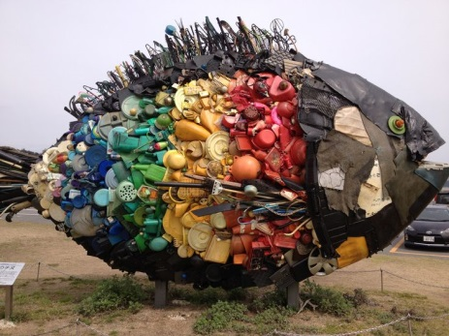
- Sculptures from waste. Set the school or your class a challenge of not throwing anything away for a week and see what sculpture you can make out of the waste – consider waste across the world and our part in that
- Read a fiction book as a class by an international writer set somewhere else in the world – use it to explore unfamiliar terms/cultural practices/way of life and research them together.
- Look at the patterns in fabrics from another country. Do a printing task where learners recreate the colours and shapes in the fabrics and add a Scottish element to their design.
- Choose another country to focus on and look at distinctive cultural themes you can build learning activities around e.g. Fabric – tartan and fabric from the other country, Flag – full of history and symbolism, Dance and music, Wildlife – compare animals that live in both countries and make masks/clay models, Art – celtic art and art from your country of choice.
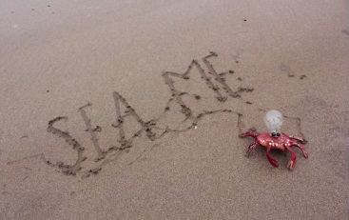
- Watch the Sea Me short animation, suitable for all ages. Consider how it made us feel and come up with ideas as to how to improve things – www.vimeo.com/123332768
Ideas for school partnerships:

- Swap curriculums with your partner school and look for topics that overlap – swap teaching ideas for that topic and plan a joint project – swap pieces of work produced by the learners
- Host a day in each school where you learn about the other culture – dance, music, history, famous people, special events
- Swap photos/paintings/drawings about harvesting vegetables in the two countries
- Choose a day where both schools will be making musical instruments from locally available recycled resources. Create a ‘Sound Garden’ at the end of the day that the rest of the school can visit to play the instruments.
- Both schools can spend the day sourcing natural items that will allow them to make marks with certain colours, e.g. plants for green, ash for black, berries for red, stone/chalk for white etc. Make papier mache using natural resources (flour glue) and paint your sculptures with your home made paint
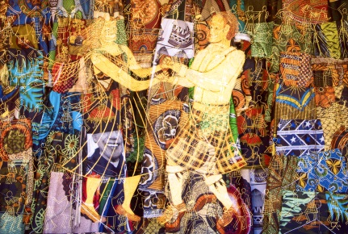
- Take pictures of the things you love about your country and ask your partner school to do the same. Swap photos and get your partner school to etch into the photo a drawing of what they love about their country and you do the same.
- Temporary art using nature – you and your partner school go out and collect leaves, stones, cones, flowers etc (anything you can find locally) and make a picture representing the other country to you. Eg. Its animals, fabric, flag.
- ½ and ½ portraits - before a teacher visits your partner school- ask the learners to draw a self-portrait of ½ their face on paper. Take the pictures out to your partner school and the learners there draw a self-portrait on the other half of the page.
Ideas for exploring fair trade
in your school:

- Design a new logo/advert/poster for a fairly traded product sold in your area – encourage your community to buy it!
- Design a comic strip showing the story of a Fairtrade farmer and why fairly traded products are so important
- Watch the Fairtrade Foundation’s new film ‘Don’t Feed Exploitation’ – how would you feel if this happened to you?
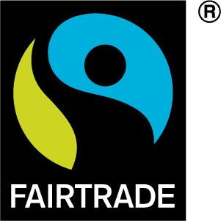
www.fortnight.fairtrade.org.uk
- Fill a shopping bag with Fairtrade products. Ask children to find out from the labels as much as they can about where the ingredients were grown and what benefits the producers received.
- Imagine yourself in a Fairtrade farmer’s shoes - play a game of ‘Breaks and Ladders’ available from www.fairtrade.org.uk/fortnight
- Find out about the famous Kilombero rice from Malawi – can your school take up the 90kg challenge?
www.jts.co.uk/our-producers/malawi-rice

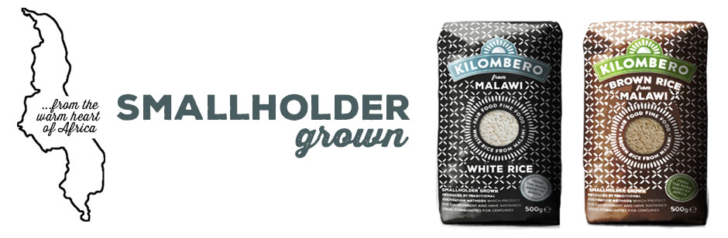

- Play the cocoa chain mystery to find out why Afia, the daughter of a cocoa farmer, can now go to school.
- Once you’ve learned about fair trade, how many SDGs do you think a fair trade system contributes to?

