CDC, the UK’s development finance institution, and our impact in 2018
This briefing provides the key results of CDC Group’s 2018 Annual Review, highlighting our contribution towards the UN Sustainable Development Goals.

About us
- CDC Group is the UK’s development finance institution, we invest in businesses throughout Africa and South Asia, where 80 per cent of the world’s poorest people live, to help advance economic development. Established in 1948, we are wholly owned by the Department for International Development (DFID).

Our work
- CDC is focused on helping to deliver the UN Sustainable Development Goals. We work to contribute to all the Goals but have a strategic focus on Ending Poverty (Goal 1) and Decent Work and Economic Growth (Goal 8). Our investments often have a wider impact, for example, providing Affordable and Clean Energy (Goal 7) or supporting Gender Equality (Goal 5).

- Countries across Africa and South Asia face a lack of jobs. In the next decade, a billion more young people will enter the job market, mainly in Asia and Africa. Many African and South Asian economies rely disproportionately on informal or sub-scale businesses. For example, the UK has over 15,000 businesses reporting revenue of more than $50 million, whereas Ethiopia has just 15 for its population of 99 million. Getting people into work will be vital for their wellbeing, giving them dignity and the means to escape poverty.

Our development impact: jobs
- By the end of 2018, we were invested in 698 business in Africa and 344 businesses in South Asia. These businesses:
- provided employment for over 850,000 people.
- had hired 32,090 people that year (2018).
- had created jobs at an average annual rate of 5.8% over the past five years, compared to a regional average growth rate of 3.1%.
- paid $4.5 billion in employee wages (2018).
- paid $3.24 billion in taxes which could be reinvested by governments in Africa and South into public services – helping in the long-term to reduce aid dependency (2018).

Our development impact: beyond job creation
- Our companies have an impact at a sector level:
- In 2018 our electricity investments generated and distributed almost 49 terawatt hours of electricity, up by 5% on 2017.
- The agriculture investments in our portfolio sourced from 1.25 million farmers in 2018.
- We make our impact go further by, where possible, encouraging private sector capital into our investments. This meant for every $100 we committed we raised an additional $41 alongside.
- We actively work with our companies to raise standards and increase their impact. We help our investees promote job quality by strengthening HR management, improving employee relations, and promoting diversity and inclusion.

Examples of our impact

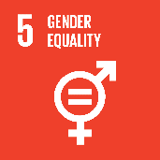
Miro | Supporting SDG 8 Decent Work and Economic Growth, and SDG 5 Gender Equality
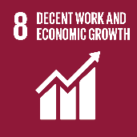
We know from our gender strategy, that women often face barriers to participation in the workforce. Working with Miro, a forestry business in Ghana, we identified that female employees were more likely to stay longer with the company and had lower rates of absenteeism. CDC is supporting the company as it introduces new programmes to empower its female employees. These include a new site-based crèche, a women’s committee and a training programme to move women from plantations to more technical roles.

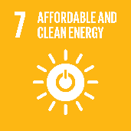
Ayana Renewable Power | Supporting SDG 7 Affordable and Clean Energy, and SDG 17 Partnerships for the Goals
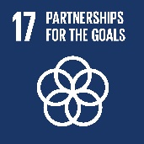
Promoting low-carbon growth by investing in renewable energy is crucial to ensuring development is environmentally sustainable. In this context, we established Ayana Renewable Power in 2017 to develop generational capacity, including in underserved states, across India. Making major progress in 2018 the company is now constructing 500MW of solar generation capacity. With a strong pipeline of renewable energy opportunities, and a management team with a track record of successful execution, Ayana was able to mobilise new capital from other investors in early 2019.

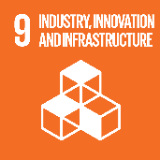
Liquid Telecom | Supporting SDG 9 Industry, Innovation and Infratsrucutre
Better digital connectivity and access to information is critical to Africa’s development and economic growth. However, digital infrastructure remains a major challenge for Africa’s people, governments, and businesses – for example, in 2016 the Democratic Republic of the Congo (DRC) had internet penetration of only 6%. We responded with a US$180 million investment in Liquid Telecom, Africa’s largest independent fibre and cloud provider with a network of almost 70,000km across 13 countries. Our investment will enable Liquid to expand into places that lack affordable access today, like the DRC and Sudan.

For further information, please contact: Toby Bateman, Global Affairs Advisor,
M: +44 (0) 7876 846 006; E: tbateman@cdcgroup.com

CDC Group (2017), Investing to transform lives: Strategic Framework 2017-2021, pg.6.

