CHIFUNDO UK AND CHANASA MALAWI
www.chanasachifundomalawi.org
FEMALE UNIVERSITY SCHOLARSHIPS FOR MALAWI
It is possible for Universities in Scotland and other UK Universities with partnerships in Malawi/Africa to place orders with Chifundo UK for Chanasa Sustainable, Fair Trade products made in Malawi so that they can be sold through gift shops or websites. All products are made by poor women in suburbs of Blantyre, Malawi. They can be chosen from a catalogue and by looking at samples. New products can be created and adaptations to an existing product can be specified. With the use of whatsapp/email, it is also possible for universities to choose their African fabric (chitenje). Products can be customized by sewing on university logos or by using metal pin ones. Quotations can also be obtained for universities to have their own material printed in Malawi but it will take a longer time for an order to be produced.
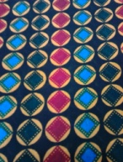
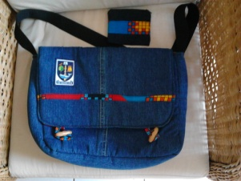
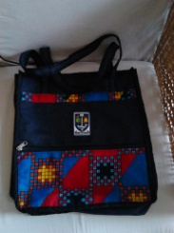
Glasgow Heritage Retail Ltd placed an order for 100 Padded Reversible Messenger Bags, 100 Modified Safari Bags and 100 purses. Glasgow University logos were supplied for the bags and metal logo pins for the purses. The retail price is double the cost price plus VAT. Glasgow University has chosen to use the profits from the sale of the products to fund female university scholarships at the College of Medicine in Malawi with the help of the SOKO Fund. They went on sale in Freshers’ Week and will be launched in early December for Christmas sales. The 2nd half of the order will be made with chitenje pictured to the left.
Universities may choose to take out any administrative charges from the profits before using them to fund female university scholarships. This means that Universities can –
- Empower the women in poor suburbs of Blantyre, Malawi
- Enable intelligent but financially challenged girls with scholarships at public funded universities in Malawi to graduate and make a difference to their families, communities and country
- Promote a message of altruism and strengthen their partnerships with universities in Malawi
- Do so at no financial cost to themselves
If you would like to make an enquiry, receive a catalogue or place and order please
CONTACT: Susan Flynn sflynn@waitrose.com Tel: 01244 381490

