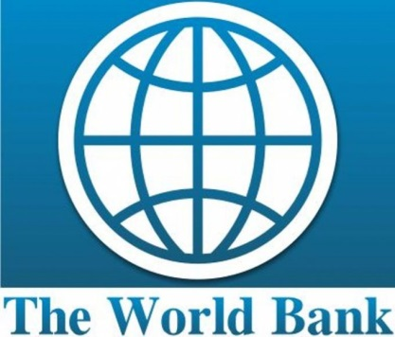

Background information on the NCHE and the WB’s “Skills Development Project”

The National Council for Higher Education

The Council was established by an Act of Parliament No. 15 of 2011, with the primary purpose of regulating the Higher Education sub-sector. Specifically, it has been established to promote and coordinate education provided by higher education institutions; design quality assurance systems and determine, maintain and regulate standards for teaching, examinations, qualifications and facilities; register, de-register and accredit higher education institutions; determine framework for funding public higher education and provide guidance on terms and conditions for awarding students’ grants, loans and scholarships; and harmonize student selection into public higher education institutions.
For further information visit: http://www.nche.ac.mw/
The World Bank Skills Development Project ($46 million)
The Skills Development Project for the Republic of Malawi will increase access, market relevance, and results orientation of supported skills development institutions in agreed priority areas. The two components of the project concern strengthening institutional performance and also technical assistance for system strengthening and policy reforms. Component 1 will support participating institutions in implementing sub-project grant agreements, focusing on results related to increasing access to and market relevance of programs. This first component consists of carrying out a program of specific activities to improve access and market relevance of engineering programs offered at the University of Malawi-The Polytechnic, Mzuzu University, University of Malawi-Chancellor College, Lilongwe University of Agriculture and Natural Resources, and at the Technical, Entrepreneurial and Vocational Education and Training Authority. Sub-project grant agreements will specify each institution's distinct mission, the scope and focus of its educational provision, the labour market areas for which each institution prepares graduates, and expectations of its performance (access, relevance and efficiency).
Component 2 will focus on systems strengthening and policy design in the skills development areas. This second component consists of the following:
- carrying out a program of activities to strengthen the capacity of the National Council for Higher Education for project implementation;
- developing and installing a management information system at the National Council for Higher Education and providing associated training;
- developing monitoring and evaluation systems and piloting new monitoring tools at the National Council for Higher Education and Participating Skills Development Institutions;
- providing technical assistance for the development and implementation of a student financing
For further information visit: www.worldbank.org/en/news/loans-credits/2014/06/19/malawi-skills-development-project

