Communications & Engagement Officer
Application Pack
February 2023

- Welcome
- What are we and what do we do?
- Job Description
- Purpose of Role
- Person Specification
- Essential & Desirable Skills

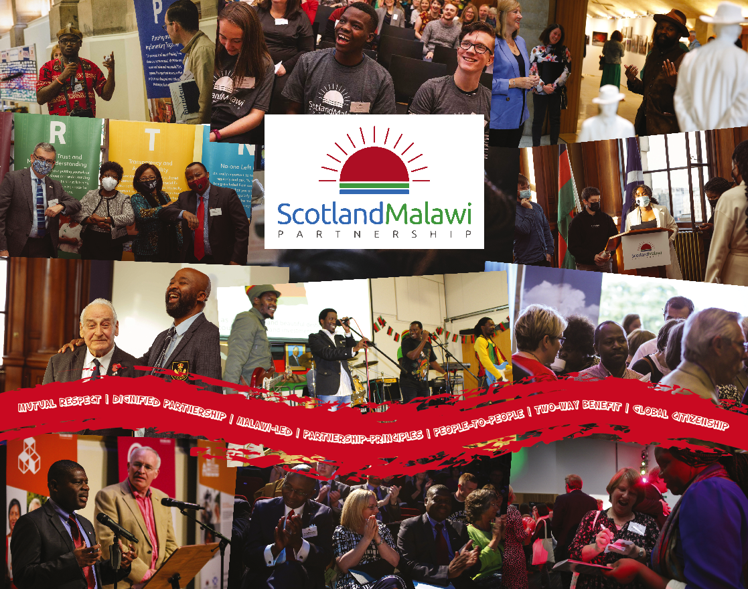

WELCOME!

Thanks very much for taking an interest in The Scotland Malawi Partnership (SMP) and for considering applying for this vacancy with us. Please consult the application procedure, job and person specification closely.

WHAT ARE WE & WHAT DO WE DO?

The SMP is an independent membership organisation, which exists to inspire, support, connect and represent the many dignified people-to-people links which exist between Scotland and Malawi for the benefit of both nations. We are ‘one side of the same coin’, working closely with our Malawi-based sister organisation, the Malawi Scotland Partnership (MaSP). who co-ordinate activities at ‘their side’ and with whom we collaborate closely. Our Partnership Principles co-designed by Malawians and Scots underpin all we do. We are funded by, but independent of the Scottish Government.

We facilitate the coming together of individuals and organisations in person and online to encourage a co-ordinated, collaborative approach, where appropriate and to reduce duplication of effort.
Ideas, activities and information can be shared on our website, social media, through our online mapping tool and in regular forums, training events and stakeholder meetings. We also provide the secretariat to Holyrood’s Cross-Party Group on Malawi to which all are welcome.

Our diverse membership which includes members of the Malawian diaspora in Scotland, have their own vibrant and impactful Malawi connections and knowledge. Members are openly searchable on our website and online mapping tool: www.scotland-malawipartnership.org/members/. Our membership includes most of the Scottish universities, many Scottish schools, NGOs, individuals, half of Scotland’s local authorities, and hundreds of churches, charities, businesses and all manner of community groups.

We are active in coordinating, representing and supporting two-way dignified partnerships across a diverse range of areas including: cultural links; diaspora leadership; environment and renewable energy; faith links; further and higher education; gender; governance; health links; local authorities; primary and secondary education; sport; sustainable economic development; tourism; trade and agriculture; water; and youth.

A 2018 University of Edinburgh study estimated that the SMP membership contributes over £49 million in time, resources and money to their links with Malawi each year. This activity directly benefits 2.9 million Malawians and 260,000 Scots annually. In total, more than 208,000 Malawians and 109,000 Scots are actively involved in links between the two countries, making the SMP one of the UK’s largest cross-community networks engaged in international development.

A separate 2018 paper, by a University of Glasgow researcher, working from a randomly selected sample of 449 Scots, found that roughly 45% of Scots could name a friend or family member with a connection to Malawi, and more than 75% of Scots were supportive of these links, with less than 1.5% opposed. There is arguably no comparable north-south, people-to-people bilateral relationship with this degree of public engagement and support.

The difference that these dignified civic society these links make in terms of combating poverty in Malawi and inspiring greater awareness in Scotland has been recognised from the outset as something immensely worthwhile. Indeed, the hundreds of Scotland-Malawi connections represent an innovative approach to international development. This is an approach based not on 'donors' and 'recipients' but on long-standing, mutually-beneficial community-to-community, family-to-family and people-to-people links, each on its own quite modest but, taken together, a formidable force for progressive change.

We are a coalition of civil society individuals and networks who believe in sustainable development through dignified partnership. We recognise the importance of the agency that individuals have to bring positive change in their communities and the transformational potential when individuals join forces in networks.

Our work is delivered by a small but highly effective staff team, and governed by a large, experienced and committed Board of Directors, elected from and by our Membership and supported by valuable Committees, including our Youth Committee. Our Board Chair is Professor Heather Cubie.

If you like the sound of what we are and do and believe that you have the values, experience and skills identified in this pack to contribute to our work, we look forward to hearing from you!
Stuart Brown
Interim Chief Executive Officer
The Scotland Malawi Partnership (SMP)

JOB DESCRIPTION:

This is an exciting opportunity for a values-driven Communications and Engagement practitioner to join the Scotland Malawi Partnership to listen to and be led by Malawians, to support and amplify the work of our members and secretariat and provide a respectful, leading voice in the Scottish international development sector.

The post-holder will build on the excellent work of their predecessors to help deliver high quality communications in support of key events as well as continuing to respond to and communicate with the SMP’s membership and other target audiences. We are a close-knit, collaborative team and whilst each individual has their responsibilities for delivery, there is also a strong emphasis on supporting one-another and ‘mucking-in’ where it’s useful.

This role requires a highly motivated, energetic, adaptable and productive individual who has the experience and ability to contribute to a small, fast-paced team. There will be a high degree of autonomy and the successful applicant will be resourceful and eager to contribute to the life and work of a busy team which is both strategic and agile in responding to members’ needs.

Following the Covid crisis, digital communications have become more important than ever. Hybrid meetings enable us to listen to and be led by Malawians and for significant participation from Malawi, the diaspora in Scotland and SMP members from the Borders to the Northern Isles. We are looking for an individual that can think innovatively about how best to use the digital space to disseminate key information, engage members and stakeholders, and share the Partnership’s core narrative.

We need someone who shares our commitment to dignified people-to-people links with Malawi, who has proven experience with a range of digital tools and platforms, who has a keen eye for detail, a passion for internationalism, and the personal drive and determination. If this sounds like you, and if you are excited about being the mouthpiece of a vibrant cross-community international development network, we encourage you to apply.

PURPOSE OF ROLE:

To deliver on the communications needs of the SMP: communicating key message to members and stakeholders, raising the profile of Scotland-Malawi links among target audiences, disseminating our core narrative, and supporting a number of high-profile events.

Communications planning:
- Agreeing with the wider team, the communications priorities at the start of each week and populating a weekly communications grid, outlining how the SMP’s messages will be delivered across the Partnership’s various digital platforms.
- Through the week, delivering this communications grid and reporting back to the team at the end of the week, to ensure full team involvement in the SMP’s messaging.
Social Media
- Managing the SMP’s social media channels, including Twitter, Facebook, Instagram, YouTube and LinkedIn
- Using social media to disseminate information and engage, inform and inspire audiences
- Manage the strategic use of social media to engage new audiences, having knowledge of metrics and paid social opportunities
Website
- Ensuring the website remains up to date, dynamic and engaging
- Working with our web developer to optimize the functionality of the site
- Managing and uploading content on the SMP website
Member Communications
- Preparing and circulating a weekly members’ newsletter
- Working strategically and proactively to develop the quality of the newsletter and its readership
Other digital engagements:
- Working innovatively to develop new digital engagements and outreach working
- Giving feedback to an externally commissioned SMP podcast
- Supporting colleagues in the promotion of their workstreams
Media
- Ensuring that positive stories about the bilateral relationship continue to appear in the Scottish Media
- Managing our ‘Friends of The Scotsman’ pieces

Photography and videography
- Commissioning from a pool of freelance photographers/ videographers
- Boosting our audience reach by focusing on more video production
- Supporting members with videography and photography
- Managing library of engaging video and photo content from SMP and member events

Strategy:
- Assisting the development of an updating Communications Strategy to help drive the Partnership’s work in this area and achieve maximum results.

Marketing and Communications
- Support the design and printing of key publications such as the Annual Report
- Collate and design reports as needed

Other
- Assisting with the collection of monitoring and evaluation data
- Monitoring and reporting on media statistics
- Other duties as required to support the SMP

PERSON SPECIFICATION:

It is essential that the Communications & Engagement Officer can:

Work effectively with others
- Act as part of a team
- Communicate and engage effectively with colleagues, partners and stakeholders
- Show respect for others

Work to the highest reasonable standards
- Take pride in the Partnership’s work
- Display professionalism while remaining personable

Be committed to the work of the Partnership
- Take responsibilities for one’s actions
- Be reliable and trustworthy
- See projects through to completion
- Be punctual and meet deadlines

Embody the vision, mission and values of the Partnership
- Show personal honesty and integrity
- Extol the spirit of cooperation by building partnerships and alliances
- Promote internationalism

ESSENTIAL & DESIRABLE SKILLS:

Abilities / skills / experience required | Essential | Desirable
Minimum 2 years’ experience working in a Media & Communications role | X
Proven capability to think innovatively, work pro-actively and deliver results | X
Excellent written and oral communication skills | X
Experienced and confident engaging mainstream media |  | X
Proven experience managing a range of digital communications platforms | X
Proven experience of using digital analytic tools to measure effectiveness and drive engagement | X
Experience of using social media as a marketing and engagement tool | X
Strong organisational skills and ability to multi-task at speed | X
Knowledge and experience of developing and managing websites and web-content | X
Experience working with photo/ video editing software |  | X
Ability to demonstrate initiative, be proactive and offer a solution-oriented approach | X
Excellent inter-personal and diplomatic skills. Professional and personable. | X
Determined and personally committed to the highest quality standards | X
Skilled in the use of MS Office applications, particularly Word, Excel and PowerPoint | X
Knowledge of Scotland’s relationship with Malawi |  | X
Experience using Wild Apricot or another digital mailing tool |  | X
Professional experience in the Scottish third sector |  | X
Knowledge, skills and experience of photography and videography |  | X

Location
The SMP’s office is located at City of Edinburgh Council, Room 3/1, City Chambers, High Street, Edinburgh, EH1 1YJ. We have blended office and home-working with the expectation of 3 days per week in the office.

Salary and Hours
The gross salary is £27,388. This is a full-time post, with a 37.5 hour working week.

Contract:
This is a fixed-term contract to 31st March 2024. We anticipate continued Scottish Government core funding beyond this date.

Reporting to: Deputy Chief Executive

Right to work
Applicants must already have the right to work in the UK through possession of an appropriate visa or residency status.

APPLICATION PROCEDURE:

Deadline
The deadline for applications is 5.30pm UK time Monday 20th February ‘23.
We shall invite those shortlisted to take part in a remote practical assessment on dates to be confirmed and selected candidates to an interview which is likely to be on Tuesday 28th February in Edinburgh City Chambers.

Please record a 2-minute video of yourself briefly highlighting:

- Your name
- What appeals to you about this role
- What specific skills & experience you have that would equip you for the post.

This can be recorded on a phone and is not testing your broadcast nor your technical skills. Its purpose is solely to help you tell us about your suitability for the role as detailed in the application pack. Please check that it’s audible and upload your 2-minute video to a private YouTube link.

To apply, please email stuart@scotland-malawipartnership.org by the deadline with:

- The YouTube link to your video
- A completed application form
- An up to date CV (2 sides of A4 max)
- Separately (NOT attached to your application as a PDF please) the equal opportunities monitoring form (completion of this equal ops form is voluntary not mandatory)

Application forms are available from:
www.scotland-malawipartnership.org/get-involved/vacancies-and-opportunities/

If you have any questions please e-mail Stuart Brown, Interim Chief Executive Officer:
stuart@scotland-malawipartnership.org

