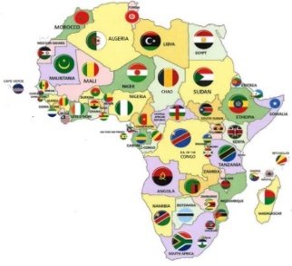
Centre for African Research on Enterprise and
Economic Development (CAREED)
School of Business and Creative Industries
University of the West of Scotland, Paisley PA1 2BE
Call for Abstracts
6th Annual Conference (Hybrid Format)
(Thursday 18th- Friday 19th November 2021)

Venue: Physical Space- UWS Paisley Campus
: Plus Virtual Participation

Theme: “Enterprise, Innovation and Structural Transformation of Africa in a Post-Covid Era”
We invite abstracts and papers from a wide range of topics relevant to enterprise and economic devolvement in Africa:
- Business and Enterprise
- Commodities and Trade (including Global Value Chains)
- The Rural Economy
- Logistics and Supply Chain Management
- Corporate Governance and Social Responsibility
- Influence of Culture and Tradition on Economic Development
- Gender and Enterprise
- International Exporting
- Small and Medium Sized Enterprises (SMEs)
- Sustainability Issues and Training
- Education and Training (Including role of the media)
Our 6th annual conference in 2021 will be hybrid-a mix of in-person and virtual participation, Physical in-person numbers will follow the UK government’s COVID-19 advice. Empirical and Conceptual papers are invited. We also encourage doctoral students and early career researchers to submit abstracts and/or research ideas for full or poster presentations. Full papers will be published in a Conference Proceedings after the conference.
Please refer to the attached template for submission guidelines.
Submission deadline for abstracts: Friday 10 September 2021
For submissions of papers please use careedconference@uws.ac.uk

Important Dates:

Abstract Submission deadline | 10th September 2021
Reviewers’ comments to author/s | 30th September 2021
Submission of reviewed abstract | 15th October 2021
Conference dates | 18th – 19th November 2021
Submission of full paper | Not later than 31st December 2021
Submission of revised full paper | TBA
;
How to Submit Abstract and Paper:
- For abstract, please follow the author guidance (Structured abstract) and use Abstract Submission Template.1
- For paper, please use Paper Submission Template.2.
(Just cut & paste your work into the template.2).
- For submission use this email: careedconference@uws.ac.uk

How to contact us:

- Director of CAREED – Professor John Struthers - careed@uws.ac.uk

- Conference Chair - Dr Adebisi Adewole adebisi.adewole@uws.ac.uk

- Conference Chairs/Organisers: careedconference@uws.ac.uk

Centre for African Research on Enterprise and Economic Development (CAREED)
University of the West of Scotland,
School of Business and Enterprise
High Street
Paisley Campus
High Street
Paisley PA1 2BE
