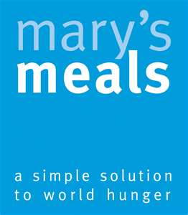
Thawale Primary School
Mulanje District, Southern Malawi

Kitchen sponsored by Lockerbie Academy
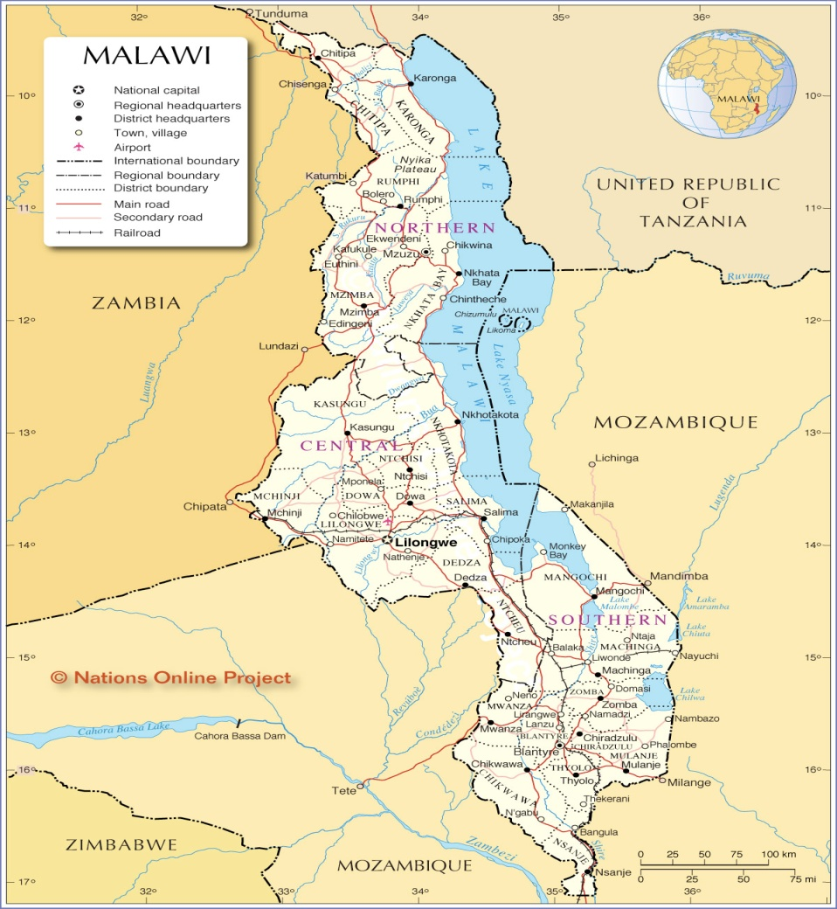

Thawale

School information:

Your school, Thawale Primary, is located in the south eastern district of Mulanje, Malawi. Mulanje is the centre of Malawi’s tea growing industry and the surrounding fields and slopes are covered in luscious green tea leaves. The most famous part of this area though is undoubtedly ‘Mulanje Massif’ or Mount Mulanje. Affectionately known as “The Island in the Sky” the 3000m high granite peak is so named because on misty days the mountain is shrouded in fluffy clouds with just the highest peaks towering above to the heavens. A truly spectacular sight and understandably it is creating a blossoming tourist interest in the area.

Your school currently has 1951 children enrolled, of whom 1015 are boys and 936 girls. The children range from Standards 1 – 8. There are 16 permanent classrooms at Thawale and your sponsored kitchen can double up as a classroom when it is not being used for feeding. Due to lack of space, some classes are held under large trees in the school grounds. The children are taught by a total of 15 teachers, who are very ably assisted by 6 trainee teachers.

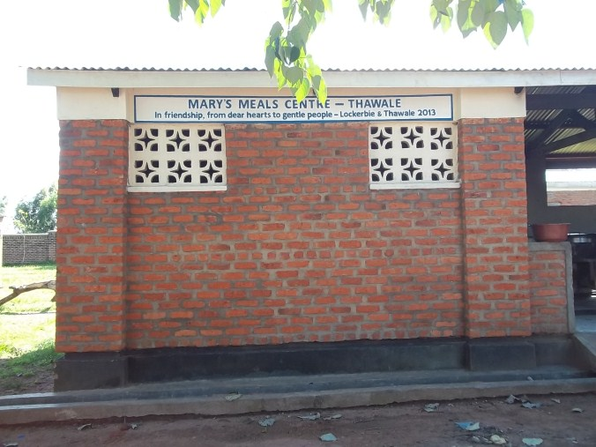

The school’s water source is a tap in the school grounds which means they have a good supply for cooking with. Thawale has a good supply of sports balls and nets for the children to play football and netball. They are lucky enough to have a good amount of land for the children to play on too.

School Kitchens in Malawi:

The kitchen is constructed from bricks and concrete and so is a permanent structure in the school grounds. When Mary’s Meals are approached to begin feeding in a school, there is a request for buy in from the local community and so they provide 10% of the bricks used. Construction takes approximately 8-12 weeks, and during this time the volunteer cooks use a temporary shelter as the school meals must be cooked undercover.
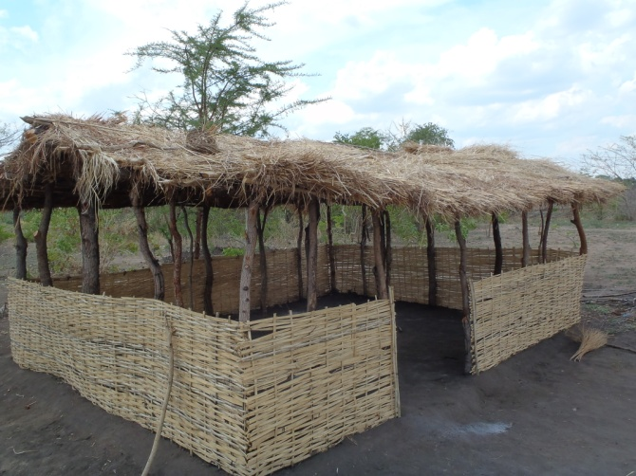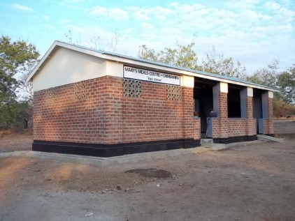
Permanent Kitchen
Temporary Kitchen

The building you have funded is made up of 3 rooms; there is 1 main room where the cooking takes place plus 2 storerooms – 1 for firewood and 1 for the storage of the Likuni Phala. These are both kept locked for security and hygiene reasons. The kitchen is fully equipped with utensils, pots, pans and mugs for the children to eat from. The children regard the mugs very highly and you can often see youngsters carrying them around on a string so as not to lose them.

The Mary’s Meals feeding programme:

Mary’s Meals is initially organised by the school’s head teacher, who then meets with the school’s committee and people from the surrounding neighbourhood. A team of volunteers are then drawn from the local community. They are split up into teams and each team takes a slot in the rota to cook the school meals. In Thawale, many of the volunteers are parents of the children at the school.

Volunteers often arrive at the school as early as 5am to fetch water, get the pots ready and start cooking. A vat of porridge takes about three hours to cook on a rocket stove. The porridge is then put into buckets, before serving to stop the children crowding around a hot stove where they could get burned. The Likuni Phala porridge is then served to long queues of children all eager to get their daily Mary’s Meal. Typically, schools in Malawi begin serving their Mary’s Meals at around 9:30am each day, feeding the youngest children first (Standard 1). After serving, the volunteers stay on to wash the pots and put away the stoves. The entire process normally finishes at about 2pm. As you can see, Mary’s Meals cooks take on a big commitment and the whole system would not be possible without the dedication of our volunteer cooks.

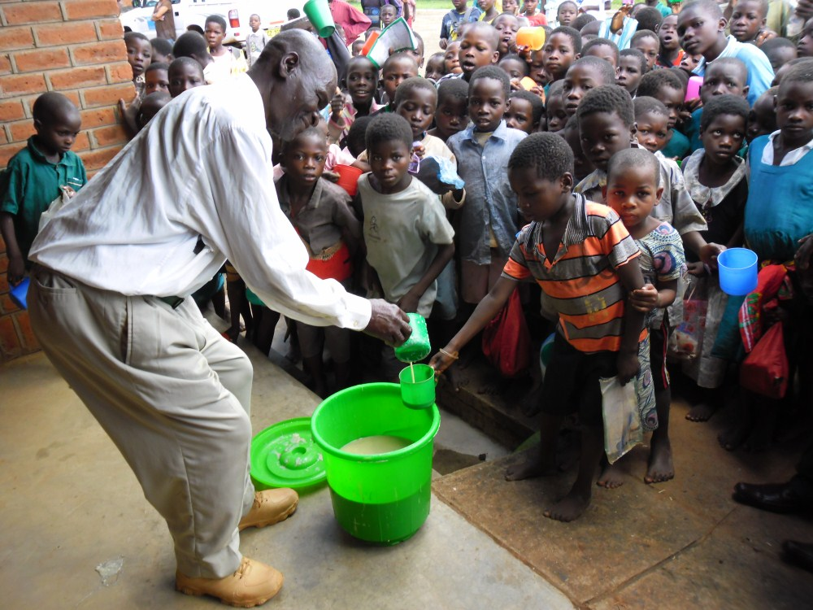

Mrs Terezina Nanyanga explains why she volunteers as a cook at Mary’s Meals at Thawale Primary:

“I help to cook for the children so they can learn from our example that working hard brings good rewards, and also I want them to benefit from good health and concentration that the meal brings them.”
Primary Education in Malawi:

All children in Malawi are entitled to free primary education. Children are allowed to start Primary School at the age of six. There are eight years of Primary School – referred to as Standard 1 – 8. To get into the next class level, children must pass end of year exams. This means there can often be a wide age range in each standard. Entry requirements for secondary school are based on children’s results in their final Standard 8 exams. For many schools, the introduction of Mary’s Meals has seen senior pupils gaining a place at secondary school for the first time ever and more and more children are winning scholarships to pay their secondary school fees. For those who don’t go on to secondary school, the level of education pupils get at Primary provides them with good employment prospects by equipping them with basic levels of literacy and numeracy as well as life and agricultural skills. The daily meals provided by Mary’s Meals allow children to attend school every day, rather than work or scavenge for food, greatly increasing their chance of finding a job and a brighter future.

The two national languages in Malawi are Chichewa and English. Children in Standard 1 – 4 are taught in Chichewa while also learning English. In years 5 – 8, they switch to lessons in English, with the addition of classes in Chichewa. The curriculum includes English, Chichewa, Maths, Life Skills and Agriculture.

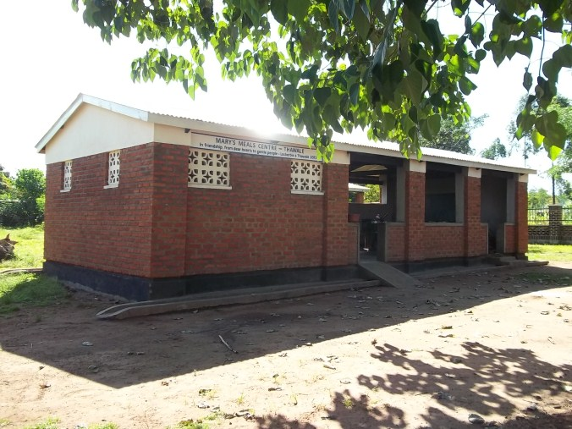
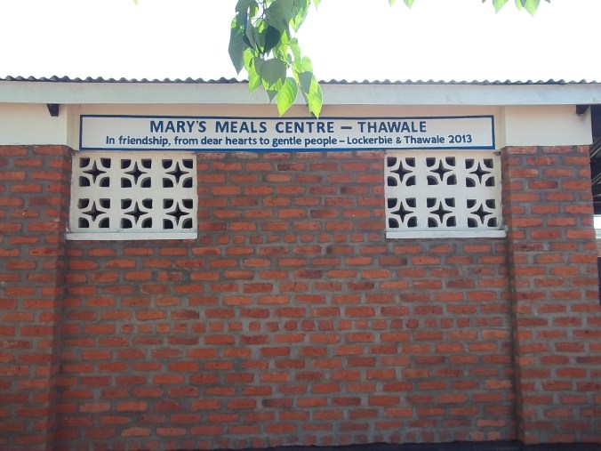
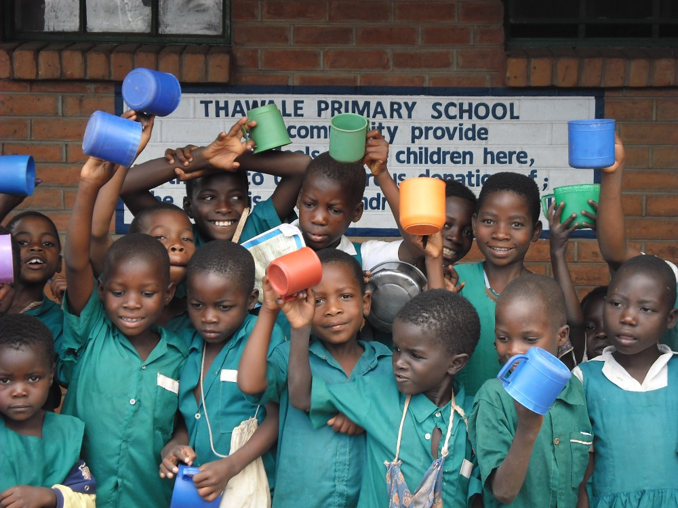

Mary’s Meals at Thawale Primary School:

Mary’s Meals began feeding at Thawale Primary School in June 2011. Deputy head teacher Effie Dinemu describes the benefits that Mary’s Meals has had on the school;

“Mary’s Meals has greatly improved classroom attendance rates and, now, absenteeism is rare. The children are learning more and are not distracted. They sit quietly and do their work”

Its not just the volunteers and teachers who are happy that Mary’s Meals are at the school, one of the pupils, Ethel, said that she loves playing with her friends and being able to learn.

Enrolment rates at Thawale:

The table below gives the enrolment rates at Thawale since 2010. As you can see the number of children has continually increased:

Year | Boys | Girls | Total
2010-11 | 900 | 827 | 1727
2011-12 | 990 | 915 | 1905
2012-13 | 1015 | 918 | 1951

Standard 8 Exam Pass Rates:

Thawale is lucky enough to offer the Standard 8 exam which determines if a child can go on to Secondary School. Since the arrival of Mary’s Meals the pass rate has gone up tremendously and the school are proud of their acheivements.

Year | No. Entered |  |  | No. Passed
 | Boys | Girls | Total |  | Boys | Girls | Total
2009-10 | 53 | 31 | 84 |  | 51 | 28 | 79
2010-11 | 76 | 57 | 133 |  | 65 | 40 | 105
2011-12 | 55 | 39 | 94 |  | 50 | 34 | 84

It is fantastic news that Mary’s Meals at Thawale enables more children to go to the school and receive the education provided there. Your kitchen sponsorship means that some of the world’s most vulnerable children need not go hungry and through education, now have the opportunity to have a bright future.

Thank You!

On behalf of everyone at Mary’s Meals, and especially from all the children at Thawale Primary School, we would like to extend our very warmest thanks for sponsoring the kitchen at your school.

What you are doing for these children is truly life changing – thank you!

