Welcome to first ever edition of the Beath Malawi Partnership Newsletter!

November 2019

After the return of the staff from their visit in the October holidays, we are now pushing on with preparations for the next staff/learner visit in 2021.

Staff returned from the trip with a real sense of purpose and were encouraged by the welcome and feedback from both our partner schools.

Mapanga PS and Njale PS have both had success in the Senior classes with a very high pass rate amongst their learners sitting the exams for Secondary School.

To help some on the road to further success were are able to support some with scholarships.

Scholarships are being well received by the learners and the local communities serving each school.

Scholarship students:

Charles Malikebu - Mapanga --> Mulanje SS
Judith Mutira - Mapanga --> Chikhwaza SS (Luchenza)
Agrella Chikono - Mapanga --> Mulanje SS
Kenneth Alexander - Njale --> Malosa
Stephano Ng'omba - Njale --> St Patricks SS
Daniel Thomas - Njale --> St Patricks SS
Peter - Mapanga --> Mulanje SS
Steven Milosi - Njale --> Zomba Catholic SS

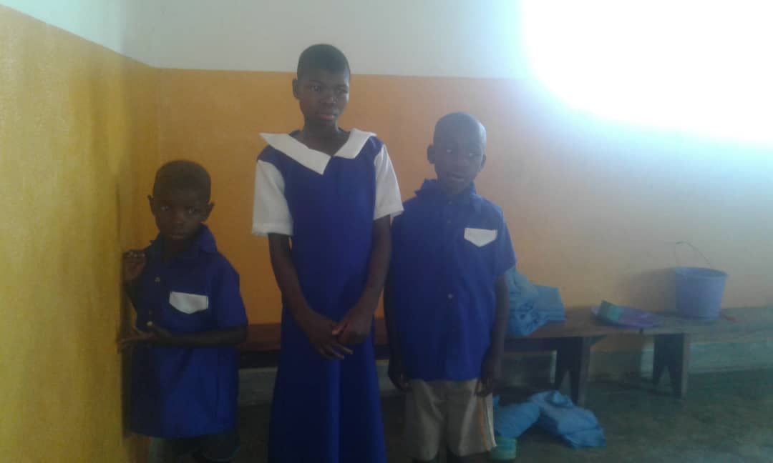
We are pleased to be supporting three learners who are deaf and have been allocated places at a special school.

They are Mphatso Misoya, Godfrey Ndalama and Eliza Ndalama.

We were able to visit the school along with some of our friends from Njale during the October visit.

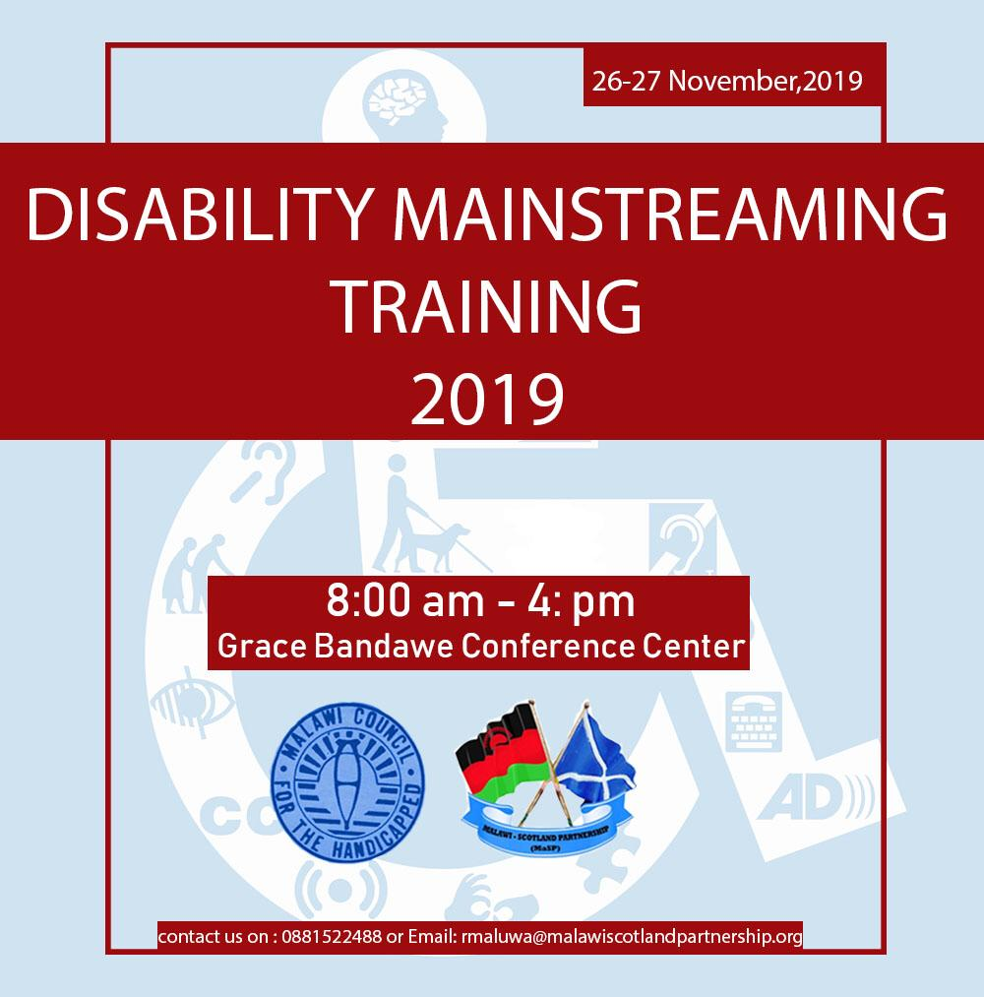

We are also able to help support our colleagues in CPD activities.

Two members of staff from each school in Malawi will attend the conference at the end of the month.

A parent meeting held on 13th November allowed discussion on the plans for 2021 – especially the itinerary.

Fund raising has already started and more will be needed.

