Scottish Parliament
Malawi Cross Party Group
Wednesday 15th June 2022
6-7pm (UK Time) / 7–8pm (Malawi Time)
Digital Meeting by Zoom

Unconfirmed Minutes:

In attendance:

- Liam McArthur MSP (Chair)
- Alasdair Allan MSP
- Alexander Stewart MSP
- John Mason MSP
- Stuart McMillan MSP
- David Hope-Jones (Secretary)
- Adam and Leah
- Ahab Kafansiyanji
- Aiko Imamura
- Alan Laverock
- Alison Greener
- Amy Earnshaw
- Anne Brown
- Austin Maloya
- Benjamin Carey
- Blesco Nyangulu
- Blessings Banda
- Calum Fisher
- Anne Casey
- Chad Morse
- Chrissie Hirst, Corra Foundation
- Cindee Rood
- Davie Luhanga
- Dellings Phiri
- Dezie Trigu
- Di James
- Donald Mavindidze
- Emma Wood
- Gaia Marini, Water Witness
- Gift Thompson
- Ieuan James
- Ishbel Smith
- Jack Norquoy, Office of Liam McArthur
- Jack Welch
- Jane Forster
- Jane Hutchison
- Jeremy Bagg
- Josephine M
- Karen MacIntyre
- lenovo
- Lilian Mackenzie
- Liza Nugent
- Lucy Hunot, Link Education
- Mark O'Donnell
- Masida Kumwenda
- Mick & Kate James, ZMCP
- Neil Gilchrist, Turing Trust
- Niall Rogerson
- Nourishing Minds, ESCA Cancer Support
- Patricia Duffy
- Peter Webster
- Ray French
- Robert Baxter
- Shupo Kumwenda
- Stuart Brown
- Sue Kevan
- Phil Timoney
- Tracy Morse
- Uchizi K
- Victoria
- Webster Moyo
- Willan Kalinda
- Yaphama

Apologies:

- John Mason MSP
- Sarah Boyack MSP
- Foysol Choudhury MSP
- Jackie Baillie MSP
- Michelle Thompson MSP
- Sharon Dowey MSP
- Rachael Hamilton MSP
- Jenni Minto MSP
- Beatrice Wishart MSP
- Katy Clark MSP

On the 15th of June 2022, the Malawi Cross Party Group (CPG) held their second meeting of this session, chaired by Co-Convener, Liam McArthur MSP. This meeting heard about an innovative, community-led and multi-party collaboration, spearheaded by Tafika, a volunteer youth organisation in Ekwendeni, Northern Malawi. The full recording of this meeting can be found here. Please click any of the below headings (highlighted in blue) to jump to the respective section of the video.
- Informal Introductions - David Hope-Jones & All
  - David opened the meeting and gave attendees the opportunity to introduce themselves briefly. David shared the news that Fiona Ritchie has been appointed as the new British High Commissioner to Malawi, and encouraged the CPG to send their well wishes to Fiona in her new role.
- Welcome, apologies & minutes of the last meeting - Liam McArthur MSP
  - Liam welcomed attendees and David listed apologies where these had been given. The minutes of the previous meeting were proposed by Alan Laverock and seconded by Ray French.
- Presentation: Tafika – Our Community’s Vision: Sharing our Story – Blesco Nyangulu, Programme Manager, Tafika
  - Blesco gave an introduction to the exciting, community-led model spearheaded by Tafika, a volunteer youth organisation in Ekwendeni. This is a story of a community wanting to educate its young people and provide them with work at the end of the process. It is about starting with the very basics and then building on this foundation by recognising Youth need purpose and pride if they are to succeed.
Tafika knew they could not do this on their own so they looked for partners willing to work with them. Their success has come from actively engaging with multiple NGOs and organisations each of which has a solution to part of the challenges facing the Tafika community. This collaboration has built strong foundations for education to be successful and has also built a sports academy which gives the Youth hope and purpose and which provided the community with an opportunity to come together to watch and share the experience of sport.
This is a community-led programme of activity and at each point in the project, the community have started by asking themselves what can they do to solve their own problems rather than looking for others to solve things for them.

- The below image illustrates the Tafika-co-ordinated, interventions of NGO partners working to help Tafika achieves its goals:

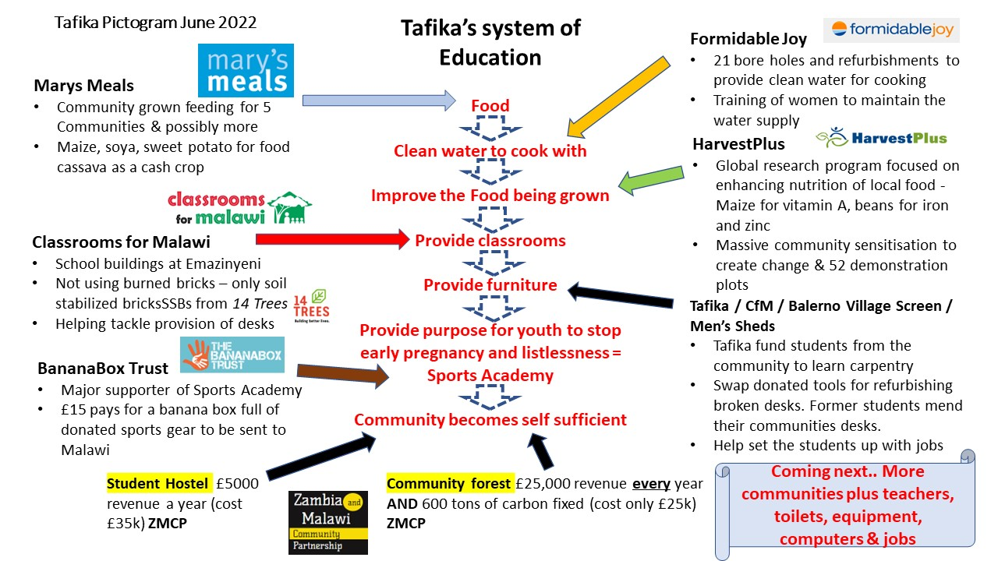

- The Malawi CPG was introduced to Speakers from five of the key organisations collaborating with Tafika, speaking predominantly from Malawi:
  - Mary’s Meals, Josephine Mpango, Programme Partners Support Officer
    - Josephine gave an overview of Mary’s Meals’ collaboration with Tafika. This brings community-grown food for 5 and possibly more communities in a school feeding programme. Maize, soya and sweet potato are grown for feeding, with cassava being funded as a cash crop.
  - Formidable Joy, Cindee Rood, Founder and Executive Director
    - Cindee gave an overview of Formidable Joy’s collaboration with Tafika. This has provided 21 bore holes and refurbishments to provide clean water for cooking, and provides training to the women of the community so that they can maintain the water supply.
  - HarvestPlus, Donald Mavindidze, Africa Regional Director
    - Donald gave an overview of HarvestPlus’ collaboration with Tafika. HarvestPlus is a global research programme focused on enhancing the nutrition of local food, and is working with Tafika to sensitise the local population on the production and consumption of biofortified crops, namely maize for vitamin A and beans for iron and zinc.
  - Classrooms for Malawi, Dezie Trigu, Country Facilitator
    - Dezie gave an overview of Classrooms for Malawi’s collaboration with Tafika. Through this partnership, they have built a block of classrooms at Emazinyeni Primary School, and aim to rennovate the four existing classrooms, build new toilets and provide new books and desks.
  - The Bananabox Trust, Willan Kalinda, Country Director
    - Willan gave an overview of The Bananabox Trust’s collaboration with Tafika. Bananabox is a major supporter of the Tafika Sports Academy, and £15 pays for a banana box full of donated sports gear to be sent to Malawi.
- Open discussion & Q&A - Liam McArthur MSP
  - Q. What are the key ingredients to the success of the project?
A. Speakers answered that the key ingredients to success included collaboration rather than competition, a shared vision, the hard work of volunteers, and being able to look at the bigger picture.
  - Q. How transferrable is this model for other communities?
A. If others want to replicate Tafika’s model, it is important to acknowledge that problems affecting one group affects the whole community, and everyone must get involved, especially the local leaders. ZMCP would like to bring in other communities to see the project in action and inspire them to adopt a similar model.
  - Q. What is the age range of the children involved in the project?
A. The children working on the project are aged 10 years and over, and the project also involves adults aged up to 80 years.
  - Q. How does Classrooms for Malawi plan to achieve economic empowerment through the partnership?
A. Economic empowerment is achieved by ensuring contractors employ local people and impart their skills before they leave.
  - Q. What funding opportunities are available to projects such as Tafika since the discontinuation of the Small Grants Programme?
A. The Scotland Malawi Partnership has published the article ‘Recommendations for supporting diversity and inclusion is Scottish Government grant-making, especially for smaller organisations and under-represented groups’.
  - Q. Are there other collaborations between NGO’s and community organisations that Tafika could learn from?
A. Tafika is an outstanding example of this type of collaboration, and a lot could be gained if more were willing to put egos and logos aside. We must step out of our comfort zones, listen as much as we talk, identify areas of collaboration and shared endeavor and find innovative ways of working together for mutual impact.
  - Q. How can Tafika connect with sports clubs in Scotland?
A. Liam McArthur and Ray French are involved with collecting football equipment and sending this to academies in Malawi. Ray shared some of his experiences so far, including interest from the Chairman of a local football team near Edinburgh in partnering with Malawi. There may be a number of Scottish teams interested in doing the same, and building personal relationships between both sides is a key aspect of this.
- Close - Liam McArthur MSP
  - Liam thanked the speakers for sharing their inspiring story, and hoped to see their model replicated by others. Liam thanked MSP colleagues and all others in attendance and closed the meeting.

