Election of Trustees at 2022 AGM: Members Briefing Pack
Saturday 26th November 2022

Executive Summary:

Six Trustees are standing down at the 2022 AGM. One of whom, Douglas Young (the current HR Committee Chair), the Board is keen to co-opt for a further year to ensure HR continuity, including in its CEO recruitment. Given the Audit and Finance Committee Chair, Claire Martin, is completing her third term as a Trustee, the Board is keen to keep this space on the Board free so they can co-opt a new AFC Chair during the year. This leaves four spaces on the Board, for which we have received three applications: Jude Turbyne, Rachel Philips and Sally Rae. If no objections from the membership, we therefore just need a proposer and a seconder for these four trustees to join the Board, at the AGM.

--------------------------------------------------------------------------------------------------------------------------------------------

Existing Board:

The Constitution of the Scotland Malawi Partnership (SCIO) allows for a Board of up to 16 Directors but can have as few as 6. A term of office for a Trustee is three years, after which they must stand down but are welcome to stand for re-election should they wish, on an equal basis with those standing for the first time.

Trustees can serve for a maximum of three consecutive terms of office, each of up to three years. After this, Trustees will be eligible for re-election again after a gap of at least one year.

Full details about the existing 16 Directors, going into the AGM, is available HERE:

1. Prof Heather Cubie (Chair)
2. Ms Claire Martin (Co-Vice Chair) *
3. Mr Douglas Young (Co-Vice Chair) *
4. Ms Susan Dalgety (Co-Vice Chair)
5. Ms Fiona Anderson *
6. Ms Chimwemwe Dorey *
7. Prof Andrew Goudie*
8. Dr Rachel Phillips *
9. Mr Tione Mtalimanja
10. Prof Jeremy Bagg
11. Prof John Briggs
12. Mr Gift Thompson
13. Dr Blessings Kachale
14. Mr Davie Luhanga
15. Dr Tracy Morse
16. Ms Emma Wood

* Directors marked with an asterisk are standing down at the AGM

Departures from the Board:

At the 2022 AGM six Directors are standing down from the Board: Claire Martin, Fiona Anderson, Chimwemwe Dorey, Andrew Goudie, Rachel Philips and Douglas Young.

We are keen to take this opportunity to express our sincere thanks to all those who are standing down at the 2022 AGM.
- Claire Martin is our longest serving Board member, having been elected in 2014, 2017 and 2020. She was an active Youth Member, dating back to her school link with Malawi when she was elected and quickly became indispensable, not least on the Audit and Finance Committee which she has chaired for a number of years.
- Fiona Anderson has given endless energy and drive, representing school and community links so well, as being an essential part of Dunblane’s brilliant links with Likhubula. Like all those standing down, she will be sorely missed.
- Chimwemwe Dorey is perhaps best known to members as one of the two co-hosts of our excellent ‘People to People’ podcast, in which she interviewed dozens of activists and stakeholders, from primary school teachers to the President of Malawi!
- Prof Andrew Goudie, as former Chief Economic Adviser both for DFID and the Scottish Government, Andrew has brought considerable expertise and government insight. He has been, and remains, a great friend of Malawi and the SMP.
- Dr Rachel Phillips has longstanding links and friendships with Malawi and has been a delight to have on the Board and on the Audit and Finance Committee – always asking just the right questions and with valuable insight and ideas.

A big thank you to Claire, Fiona, Chimwemwe, Andrew and Rachel for all your time, effort, energy and expertise.

Target areas of recruitment:

In keeping with best practice, gaps in the composition of the Board are identified through an annual review of current composition prior to the AGM. Three key questions are considered:
- Does the Board have the necessary technical skills, experience and expertise to undertake its duties?
- Is the Board broadly representative of the membership it represents?
- Is the Board sufficiently diverse?

This year the Board has identified several important gaps which it needs to fill and therefore especially welcomes applications from those with experience in:
- Finance: We are especially keen to recruit a Trustee with finance and accounting experience to join the Audit and Finance Committee and consider replacing Claire Martin, who is standing down as Committee Chair.
- Income generation: It is important that we diversify our income and reduce our reliance on the core governmental grant. We really encourage those with experience in income diversification, including accessing grant funding, to stand for election.
- Youth and Schools: school partnerships remain a key part of the SMP so we are keen to encourage nominations from those involved in school links.
- Legal experience and safeguarding: to ensure the SMP remains legally compliant, we welcome nominations from those with legal experience. Safeguarding also remains a crucial priority for SMP and we would be pleased to attract a Trustee with professional safeguarding expertise who could help lead the sector by good example.
- Smaller NGO/ community links: We hope to continue to have representatives of smaller organisations working with Malawi on the Board.

Of course, most individuals have a range of skills, many of which could be useful to SMP and which go way beyond what is listed here. It is however important to remember that being a Trustee carries responsibilities and often, talents and skills can be used to support SMP in other ways than on the Board.

Proposed Co-options:

In keeping with the SMP’s constitution, the Board can co-opt members to serve until the next AGM.

The SMP is soon to embark on a CEO recruitment process, given the departure of David Hope-Jones in the new year. The Board is therefore keen to co-opt Douglas Young (the current HR Committee Chair) back to the Board for a further year. This will give important continuity at a crucial time for the charity.

Given Claire Martin, the Chair of the Audit and Finance Committee (AFC), is standing down as a Trustee following the completion of her third term of office, the Board is keen it retains financial expertise and a direct link to the AFC. We have not received a nomination from someone with financial expertise who could chair this important committee. The Board therefore proposes to keep this space on the Board free so it can co-opt someone during the year.

Recruitment process:

Over recent weeks, all SMP Members have been invited to stand for election by email, in the bulletin, on the website and across various social media channels.

The Board has received three excellent nominations to stand: Jude Turbyne, Rachel Philips and Sally Rae. Full details for all four is given in the following pages.

Member approval process:

We have six vacancies on the Board at this AGM.

It is proposed that:
- Douglas Young be co-opted for 12 months.
- The Board is able to co-opt another during the year to lead with finance and Chair the AFC.
- Jude Turbyne, Rachel Philips and Sally Rae are all elected to the Board, from the remaining four places.

Given there is no competition for places, there is no need for a formal vote. At the AGM we will therefore ask if any questions or objections to this process, and then simply a proposer and a seconder for the above.

The SMP has worked to ensure this process is as transparent, accountable and rigorous as possible.
APPLICATIONS TO STAND FOR THE BOARD:

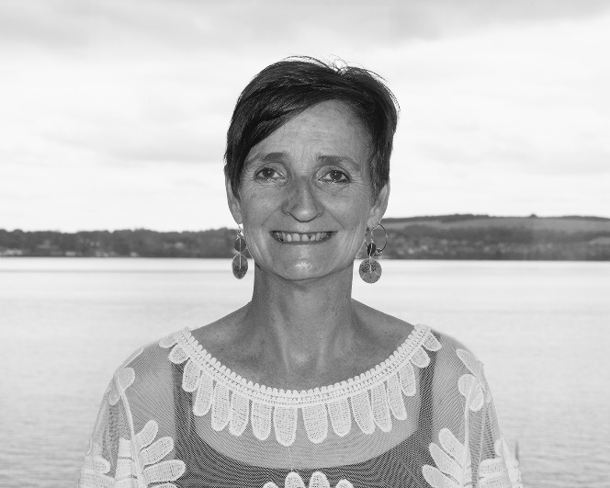
Dr Judith Turbyne

CEO of Children in Scotland; former Head of Engagement with the Scottish Charity Regulator (OSCR); current member of the SMP’s Safeguarding Committee.

Areas of expertise include:

- Safeguarding / legal
- Financial expertise/ income generation
- Governance
- Government/parliament engagement
- NGO activity
- Community engagement

Personal statement:
I have spent the majority of my professional life working for, volunteering for or studying the charity and voluntary sectors.

I am driven by a passion for social justice. This passion took me initially volunteering in community development in Guatemala. That started me on a journey of working in international development and solidarity which ultimately led me to work for Christian Aid in Latin America and the Caribbean before working as the CEO of Progressio Ireland (international development organisation). My passion came from my desire to contribute to authentic partnerships between North and South to challenge the situations and structures that keep so many people poor and marginalised both at home and abroad.

I came back to Scotland to be closer to family and spend eight years working as Head of Engagement with the Scottish Charity Regulator (OSCR). In that role I had the privilege of engaging with charities across Scotland, trying to build a listening, proactive and preventative regime. During my time there, I lead the Regulator’s work on Safeguarding, out of which came a new piece of guidance for the sector.

I left to take up the role as CEO with Children in Scotland, which has been a wonderful new challenge.

I have a PhD that looked at empowerment in development. I am currently deputy Chair of the Corra Foundation and have gained a great deal of experience in governance through my time on that board.

What I miss in my current roles is an involvement in international solidarity. I would love to offer my time and skills to the board of SMP where solidarity is at the heart of the work.

I would bring a number of skills to the board. I have a good knowledge of governance both from my work with the regulator, but also my experience on boards. I have a strong grounding in safeguarding and what that means for charities in Scotland. I have good financial management skills and have managed the fundraising function in a number of charities.

Application supported by: Heather Cubie
Application seconded by: Fiona Anderson

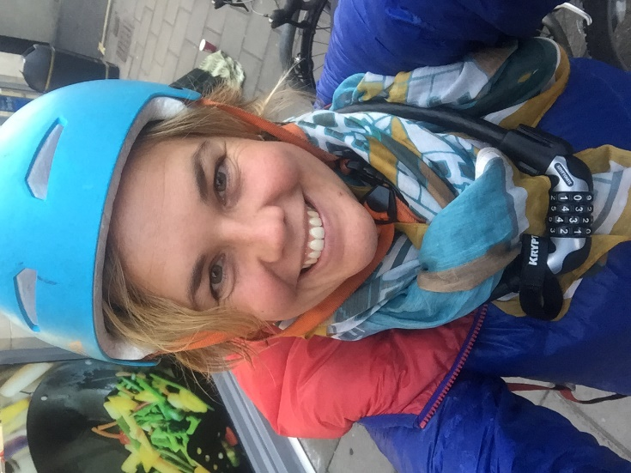
Dr Rachel Philips

GP with extensive knowledge and experience of Malawi; completed one term as SMP Board Member; current SMP Audit and Finance Committee member.

Areas of expertise include:
- Health links
- Further and Higher Education links
- Diaspora engagement
- Malawian culture and language

Personal statement:

I was born in Lilongwe Central Hospital in 1984 to Irish and Scottish parents who lived in Malawi from 1960s to 1990s. I left when I was 11 but like many displaced diaspora became passionate about my original home and have travelled back 11 times.

My continued interest in Malawi, Subsaharan Africa and politics, led me to take a couple of years out from my medical training in Edinburgh. Between my 2nd and 3rd year I chose to undertake an intercalated BSc at University College London UCL where I was awarded First Class Honours in International Health. And then later on, before my final year, I spent a year in South Africa volunteering for Treatment Action Campaign (TAC) - the largest NGO in South Africa that campaigned for a national roll out of antiretroviral medication in the public sector during a period of governmental AIDS denialism.

I am now a GP here in Edinburgh with an interest in Medical Education and Postgraduate Training in Primary Care. I have maintained personal links with Malawi but am keen to find a constructive channel for my experiences in, and passion for, the country of my birth. I would hope to add value by being a young professional female with medical, communication and eductional skills and a familiarity with Malawian culture and language.

Application supported by: Heather Cubie
Application seconded by: Susan Dalgety

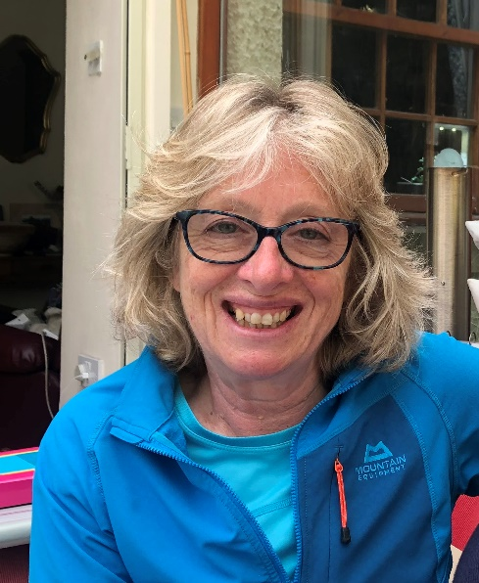
Mrs Sally Rae

Secondary school teacher responsible for developing George Watson’s College Malawi links; active supporter of the SMP’s work with schools, with strong focus on respectful two-way youth dialogue.

Areas of expertise include:
- Youth and schools
- Health links
- Primary and secondary education

Personal statement:

I first fell in love with Malawi in 2011 when Linda MacDonald ( MUMS) encouraged me to consider Malawi as a venue for the GWC annual school trip. After two weeks’ visiting various MUM’s feeding stations, 500 Miles Clinic and a range of accommodation from the back of a bicycle taxi and a matola, I knew Malawi would be perfect.
I have since organised eight trips, each growing in popularity to the point we now take 44 pupils. Over two weeks, we visit schools, clinics and infant homes in Lilongwe, Blantyre and Mangochi, climb Mount Mulanje and Zomba and enjoy some downtime at Mvuu. We have made changes to the trip over the years often with the help of the SMP & always doing our best to follow the SMP partnership principals.
We now have excellent relationships with: Achikondi Clinic; Open Arms; Bolera Palms and Thom’s Colourful Classrooms; MCV; STEKA; Zomba TREEZ and MCT Scores Football and Kalula Queens in Lilongwe, amongst others. All made possible through the support of Aaron Nyandere.
I would love to offer other schools considering a visit to Malawi the benefit of all this experience.
I spent an extended sabbatical with Open Arms in 2013 and since then I have organised trips for adults who have been inspired to learn more about our activities in Malawi.
I am also supportive of the British Council Connecting Classrooms initiative. We have created a six way relationship between Bruntsfield Primary, Tynecastle School, GWC, Bolera Palms, St Andrews and MCV. Post Covid, we are keen to breathe new life into this, beginning with a letter exchange now underway between Bruntsfield and Bolera Palms in Mangochi.
In my current role as school nurse at George Watson's College I provide supervisory support for their extensive outdoor education programme. As such, I have good relations with teachers throughout the school. They will testify to my passion for Malawi, a willingness to help wherever I am needed and a practical, resilient mindset.
If these skills are of value to the Scotland Malawi Partnership, then I would love to join you.

Application supported by: Claire Collins Open Arms Malawi
Application seconded by: Olivia Giles 500Miles

